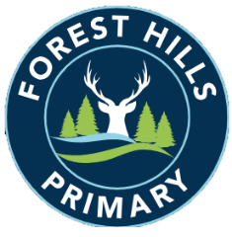
Forest Hills Primary School
Long Term Planning - Art - 2023-24
Cycle A
Subject | Autumn |  | Spring |  | Summer
KS1 | Colour | Line | Architecture | Style in Art | Paintings of Children | Sculpture
LKS2 | Line | Still Life and Form | Art of Ancient Egypt | Anglo Saxon Art | Architecture | Modern Architecture
UKS2 | Style in Art | Art in the Italian Renaissance | Renaissance Architecture and Sculpture | Impressionism and Post-Impressionism | Victorian Art and Architecture | William Morris

Long Term Planning - Art - 2024-25
Cycle B
Subject | Autumn |  | Spring |  | Summer
KS1 | Colour and Shape | Colour, Shape and Texture | Portraits and Self-Portraits | Landscape and Symmetry | History Painting | Murals and Tapestry
LKS2 | Light | Space | Design | Monuments of Ancient Rome | Monuments of the Byzantine Empire | Embroidery, Needlework and Weaving
UKS2 | Print Making | Islamic Art and Architecture | Chinese Painting and Ceramics | Photography | Art from Western Africa | Art in the 20th Century

