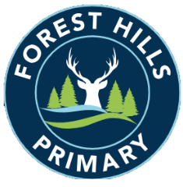
Forest Hills Primary School
Long Term Planning – Modern Foreign Languages: Spanish - 2023-24
Introductory Year 1
Subject | Autumn |  | Spring |  | Summer
KS2 | Phonics 1 & 2  I am Learning Spanish | Animals | I Know How to… | Fruits | Seasons | Presenting Myself

Long Term Planning - Modern Foreign Languages: Spanish - 2024-25
Introductory Year 2
Subject | Autumn |  | Spring |  | Summer
KS2 | Phonics 1 & 2  Instruments | Seasons | Vegetables | Ice-Creams | In the Classroom | Habitats

Long Term Planning - Modern Foreign Languages: Spanish - 2025-26
Cycle A
Subject | Autumn |  | Spring |  | Summer
LKS2 | Phonics 1 & 2  I am Learning Spanish | Animals | I Know How to… | Fruits | Presenting Myself | Habitats
UKS2 | Phonics 3 & 4  Presenting Myself | Family | At the Cafe | Olympics | The Weekend | Vikings

Long Term Planning - Modern Foreign Languages: Spanish - 2026-27
Cycle B
Subject | Autumn |  | Spring |  | Summer
LKS2 | Phonics 1 & 2  Instruments | Seasons | Vegetables | Ice-Creams | My Family | In the Classroom
UKS2 | Phonics 3 & 4  The Date | Do you Have a Pet? | My Home | What is the Weather? | At School | Me in the World

