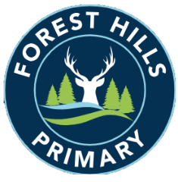
Forest Hills Primary School
Long Term Planning – PSHE - 2023-24
Cycle A
Subject | Autumn |  | Spring |  | Summer
KS1 | Me and My Relationships | Valuing Difference | Keeping Myself Safe | Rights and Responsibilities | Being My Best | Growing and Changing
LKS2 | Me and My Relationships | Valuing Difference | Keeping Myself Safe | Rights and Responsibilities | Being My Best | Growing and Changing
UKS2 | Me and My Relationships | Valuing Difference | Keeping Myself Safe | Rights and Responsibilities | Being My Best | Growing and Changing

Long Term Planning – PSHE - 2024-25
Cycle B
Subject | Autumn |  | Spring |  | Summer
KS1 | Me and My Relationships | Valuing Difference | Keeping Myself Safe | Rights and Responsibilities | Being My Best | Growing and Changing
LKS2 | Me and My Relationships | Valuing Difference | Keeping Myself Safe | Rights and Responsibilities | Being My Best | Growing and Changing
UKS2 | Me and My Relationships | Valuing Difference | Keeping Myself Safe | Rights and Responsibilities | Being My Best | Growing and Changing

