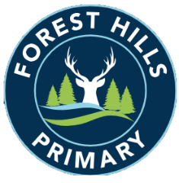
Forest Hills Primary School
Long Term Planning - Cycle A - 2023-24
Year 1/2
Subject | Autumn |  | Spring |  | Summer
Science | The Human Body | Animals and their Needs | Seasons and Weather | Taking Care of the Earth | Plants | Materials and Magnets
History |  | Discovering History |  | Kings, Queens and Leaders |  | Parliament and Prime Ministers
Geography | Spatial Sense |  | The UK |  | The Seven Continents
Art | Colour | Line | Architecture | Style in Art | Paintings of Children | Sculpture
D&T | Dips and Vegetables | Jam Tarts / Mince Pies |  | Animal Sock Puppets |  | Vehicles
Music | Hey You! |  | In the Groove |  | Friendship Song
PE | Gymnastics  Team Games |  | Dance  Gymnastics |  | Multi-skills  Athletics
Computing  Purple Mash | Online Safety a& Exploring Purple Mash (4)  Effective Searching (3)  Lego Builders (3) |  | Technology Outside School (2)  Grouping and Sorting (2)  Creating Pictures (5)  Spreadsheets (3) |  | Coding (6)  Coding (5)
RE | Caring  Values and commitments | Belonging  Identity, diversity and belonging | Celebrations  Practices and ways of life | Families  Meaning, purpose and truth | Answers  Beliefs, teachings and sources | Worship  Practices and ways of life
PSHE | Me and My Relationships | Valuing Difference | Keeping Myself Safe | Rights and Responsibilities | Being My Best | Growing and Changing
 | Other issues and sessions will also be led in response to the emerging needs of the class.

