Assessment and
Strategic Marking Policy
September 2025 - 2026


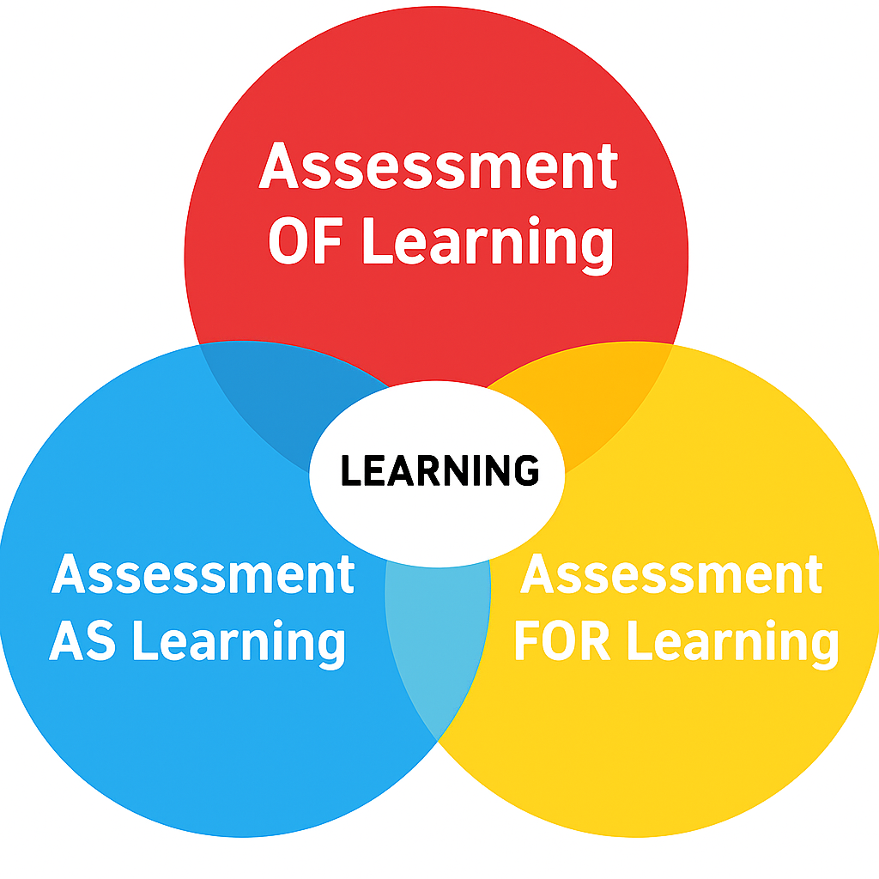
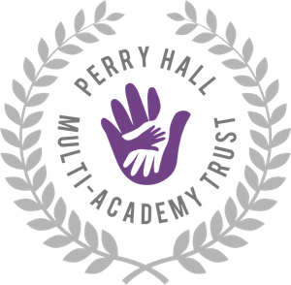

Title | Assessment and Strategic Marking Policy
Author | PHMAT
Date Approved | September 2025
Approved By Name | Ashley Knibbs (Chair of Governors)
Next Review Date | September 2026

Rationale
Assessment in all its forms is a powerful way of raising pupils’ achievement and enabling progress. It is based on the principle that pupils will improve most if they understand the steps to achieving their learning outcome, where they are in relation to this aim, and how they can achieve it.
Effective assessment is inherent to high quality teaching and learning and is embedded in pedagogy. All forms of assessment serve to raise standards in pupil achievement and enable pupils to be successful.
Assessment is the process of seeking and interpreting evidence for the use by pupil and teachers to decide where the pupils are in their learning, where they need to go and how to best get there.
We recognise and value the components of the assessment process as:
- Assessment for Learning (Formative/Responsive Teaching)
- Assessment as Learning (Formative – pupil involvement, peer and self-assessment)
- Assessment of Learning (Summative)
- Feedback for Learning (Verbal and written feedback and marking)

Assessment for Learning (Formative Assessment/Responsive Teaching)

Assessment for Learning (AfL), also termed formative assessment or responsive teaching, enables teachers to use information about pupils’ knowledge, understanding and skills to adjust teaching and learning processes in real time, improving outcomes for all regardless of starting points. It is a continuous process that happens naturally throughout lessons via observation, questioning, discussion and analysis of work.
Effective formative assessment is dynamic, evolving in response to pupils’ needs. Teachers must know how well pupils are progressing and ensure that pupils themselves understand how they are doing and what they need to do to improve. As Dylan Wiliam notes, “the shorter the time interval between eliciting the evidence and using it to improve instruction, the bigger the likely impact on learning.”
AfL is integral to raising standards where pupils have a clear sense of themselves as learners, understand the goals they are working towards, and are equipped with the knowledge and tools to reach them. For this to be successful, it must be planned, purposeful, and acted upon quickly.

Our Approach to AfL
We believe that effective formative assessment is a key factor in driving pupil progress and improving outcomes. Within our classrooms, AfL is used to:
- Evaluate pupils’ knowledge and understanding and quickly identify misconceptions, gaps or next steps for challenge.
- Consistently and swiftly respond to pupils' needs, addressing misconceptions or knowledge gaps and reshape activities (tasks, plans, resources, etc) at the point of learning to meet evolving pupil needs.
- Adapt lessons and planning, ensuring appropriate differentiation of objectives, questions, tasks, pedagogy and resources.
- Promote pupil engagement by showing the value of the learning process and instilling the belief that all pupils can overcome barriers and continuously improve.
- Help pupils understand how well they are doing and what they need to focus on to move forward.
- Provide timely, constructive feedback (verbal, live or written), that leads pupils to take action.
While not all formative assessment will be formally recorded, it will always be used purposefully to inform instruction.

AfL Strategies Used Across the School
Examples of AfL in action include, but are not limited to:
- Pre-assessments and questioning to inform pre-teaching.
- Rich, open-ended questioning and answer sessions which probe understanding.
- Thinking time (6–10 seconds minimum) before gaining pupil responses.
- ‘Cold calling’ or using no hands up to ensure all pupils are engaged.
- Scaffolded feedback that develops the learner rather than simply correcting the work through pupil conferencing to gauge their level of understanding of concepts, to celebrate progress and to identify and unpick misconceptions and/or barriers to learning.
- Retrieval practice through quizzing and low-stakes testing.
- Talk strategies like ‘Think-Pair-Share’, nesting or use of talk partners.
- Implementation of a range of checking for understanding strategies, for example:
- whole-class responses (i.e. use of mini-whiteboards, ABCD fingers)
-choral response
-agree/disagree
-exit ticket
-my favourite mistake
-say it better again
-explain or defend
-summarise so far.

What Successful Assessment for Learning Looks Like
- A range of effective strategies used to check for understanding (some examples listed above).
- Insightful and responsive questioning.
- Timely and purposeful feedback (often live or immediate).
- Clear understanding among pupils of what they are learning and why.
- Pupils being appropriately challenged and supported.
- Opportunities for pupils to reflect on and respond to feedback.
- Teaching informed by ongoing assessment.
- Pupils making rapid and sustained progress - demonstrating progress over time.

Assessment as Learning

Assessment as Learning involves pupils in the learning process where they monitor their own progress, ask questions and practice skills. Pupils use self and peer assessment and teacher feedback to reflect on their learning, consolidate their understanding and work towards personal targets.
To achieve this, we will use assessment as learning:
- to involve both teacher and pupil reviewing and reflecting on performance and process
- to communicate the learning objective and encourage pupils to evaluate their progress so that they understand the next steps they need to make
- to encourage pupils to evaluate their own work based upon specific criteria across the curriculum
- to encourage pupils to listen to the range of pupils’ responses to questions
- to use examples of work from other pupils in the class, highlighting the ways it meets the learning objective/assessment criteria.

Self- assessment and peer assessment – adults will:
- help pupils to identify any gaps between actual and optimal performance
- show pupils how the learning objective / assessment criteria have been met in some examples of work from peers
- allow pupils time to work out problems using a range of strategies, whilst not solving problems for them
- provide opportunities for pupils to develop confidence in judging their performance and practice self-assessment skills in context
- encourage pupils to use a green pen to self-assess and review their own work when appropriate.

Assessment of Learning (Summative)

Assessment of Learning happens at the end of each term and year. Teachers evaluate pupils’ learning and progress in order to judge whether pupils are on track to meet their end of year expectations, and whether planning and teaching has been effective.
Summative assessment refers to the assessment of pupils where the focus is on the outcome of the learning at the end of a period of time relevant to learning aims or national standards. This contrasts with formative assessment which summarises the pupils’ development at a particular point time.

We will use assessment of learning:
- to formally assess and record pupil achievement and standards in all subjects
- to determine pupil progress against age related expectations and national standards starting points
- to target and tackle underachievement, identify and overcome barriers and address areas of weakness in teaching and learning
- to inform school self-evaluation
- to inform parents of pupil achievement to include them in supporting their pupil’s learning.

To ensure our assessment of learning is effective, we:
- conference pupils to gauge their level of understanding of concepts, to celebrate progress and to identify and unpick misconceptions and/or barriers to learning.
- complete termly standardised assessments for each pupil in reading, spelling and maths (ensuring that assessments are question level analysed, outcomes of assessments are shared with pupils, assessment papers are revisited with pupils and future planning considers the outcomes of assessments)
- carry out end of unit assessments for science, foundation subjects and maths
- triangulate work in books, outcomes from standardised tests and knowledge of the pupil to come to a summative judgement for reading, writing, maths and science
- through professional dialogue, use a range of evidence to moderate judgements (against standardisation material) as a school and in addition, with other schools for EYFS, Year 2 and Year 6. Moderation is a crucial process that ensures teachers' assessment judgments are accurate, consistent, and aligned with national standards. This process helps maintain consistency within the school, across different schools, and with national benchmarks.
- carry out pupil progress meetings to discuss validated outcomes, celebrate successes, identify any needs, next steps and teaching/intervention strategies which are then regularly reviewed.
Teacher Assessments
End of term teacher assessment judgements are made for pupils in KS1 and KS2 for Reading, Writing, Mathematics and Science – these are recorded on Arbor.
End of year judgements are also made for pupils in KS1 and KS2 for all subjects although these are not recorded on Arbor.

The following codes are used:

EM  Below the Standard  (Engagement Model) | Some children who are working below the standard of national curriculum assessments and are not engaged in subject-specific study will be assessed using the Engagement Model.
BLW  Below the Standard (working within National Curriculum) | A child is working below age related expectations. The child will be working below their year group curriculum.
WTS  Working Towards Standard | A child is working towards age related expectations. They are not yet secure in most/all of them.
EXS  Expected Standard | A child is working in line with age related expectations. They have achieved what has been taught so far and are ‘on track’ to meet age related expectations by the end of the year.
GDS  Greater Depth Standard | A child is working at greater depth within their age-related expectations.

What Assessment Happens when?
Day to Day | Every Half Term | End of the Term | End of the Year
- Feedback and marking  - Responsive teaching/adapting lessons  - Pre-teach  - Catch up intervention or CTG activities  - Planned interventions | - End of unit assessment (Maths, Science, Wider Curriculum) gap analysis activity  - Times table/MTC tracker (Y3-6, Y2 from Summer Term onwards)  - Phonics assessments | - Standardised tests for Reading and Maths gap analysis activity  - Wellcomm assessments  - Reading fluency assessment  - Books banding assessment  - Spelling – KS2  - Handwriting  - Teacher assessments (following moderation) | - Same actions as end of term  - Cross moderation with other local schools  - Transition meeting between current and new teacher to share key information.
Any specialist assessments if required, for example, Tobans, CAML-yl, COPs, BPVS and Renfrew etc.
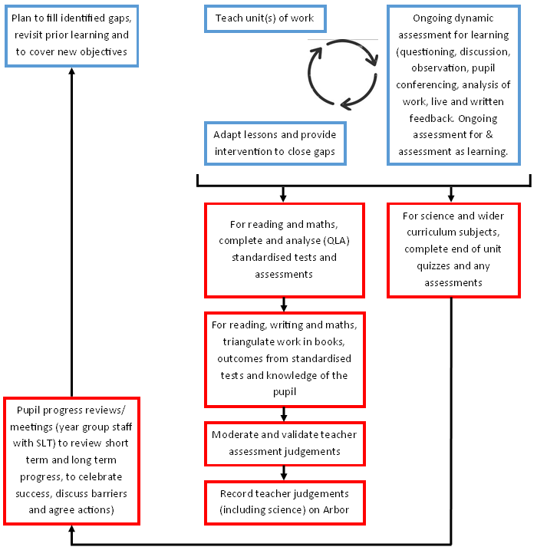
Formative and Summative Assessment Cycle

Attainment
Using teacher assessment judgements, attainment - the benchmark a pupil has achieved against the assessment criteria at the end of a school term/year (as above) – will be measured considering the proportion of pupils who are working at each of the above stages and also the ‘average attainment’ for a cohort or group of pupils.

Progress
Progress is a relative measure that refers to how much progress a pupil has made from their initial starting point e.g. KS1-KS2 or EYFS-KS2, year on year and at the end of each phase. It refers to the difference between where a pupil started from and where they have reached.

Some examples, across a year:

Baseline  Start Point | End of Autumn Term (CP2) | End of Spring Term (CP4) | End of Summer Term/End of Year (CP6) | Measure of Progress (Baseline-CP6)
EXS | EXS | EXS | WTS | Less than expected progress
WTS | WTS | WTS | WTS | Expected  progress
EXS | EXS | EXS | EXS | Expected  progress
WTS | WTS | WTS | EXS | Better than expected progress
EXS | EXS | GDS | GDS | Better than expected progress

Objectives in each phase are progressive. Each phase builds upon the previous one. If pupils are expected at the end of each phase, then they are making expected progress.
Whilst children maintaining working towards are making expected progress, the school aims to progress all children to make expected or above.

EYFS
Within the Early Year Foundation Stage:
- Initial/baseline assessment in Nursery and Reception, which will be completed in the first three weeks of the Autumn Term
- Staff will use Development Matters and EYFS Statutory Framework programmes of study to form teacher assessment judgements of children’s development, termly
- At the end of Reception, the Early Years Foundation Stage (EYFS) Profile assessment will be carried out, summarising a child's development against the 17 Early Learning Goals (ELGs) across seven areas of learning
- Wellcomm is used to assess the children’s speech and language development every term.

EYFS Expectations
 | Baseline | End of T1 | End of T2 | End of T3 | End of T4 | End of T5
Terrific for Twos  (-3) | 0-3D | 0-3D | 0-3D | 0-3S
Nursery (-2)  5 terms | 3-4E | 3-4D | 3-4D | 3-4D | 3-4D/S | 3-4S
Nursery (-1)  3 terms | 3-4E | 3-4D | 3-4D | 3-4S
Reception (0) | Reception E | Reception D | Reception S | ELG

RAPS

Aspirational predicted targets are generated from the End of Year CP6 teacher assessment data for the following academic year. These targets focus on improving pupil performance and achievement and will be linked to end of key stage targets, narrowing any gaps over time. The Headteacher, alongside the SLT, is responsible for the setting and ongoing monitoring of these targets with collaborative input from staff members directly involved with the pupil.

Nationally Standardised Summative Assessment

Nationally Standardised Summative Assessment enables:
- School leaders to monitor the performance of pupil cohorts, identify where interventions may be required, and work with teachers to ensure pupils are supported to achieve sufficient progress and attainment.
- Teachers to understand national expectations and assess their own performance in the broader national context.
- Pupils and parents to understand how pupils are performing in comparison to pupils nationally.

Children will sit in:
- Reception- Baseline Assessment (RBA)
- End of Reception – EYFS Profile
- Year 1- Phonics Assessment (and in Year 2, if expected standard not met in Year 1)
- Year 4- Multiplication Tables Check (MTC)
- Year 6 – End of Key Stage 2 SATS.

Formal Reporting
Reporting is communication about the outcomes of pupils assessed learning at a given point in time. We adopt a range of both written and verbal reporting, formally and informally.
Reporting will include:
- Records/outcomes of pupil progress meetings
- Subject leader end of term subject analysis and end of year curriculum reviews
- Senior Leadership Team whole school data analysis reports and qualitative reports for year groups, school self-evaluation and governors
- Learning consultations for parents and pupils in the Autumn and Spring terms
- Annual written reports to parents in the summer term including the option of a learning consultation.

Incisive Feedback for Learning and Strategic Marking

Feedback provides learners with information about their performance. Formative assessment helps pupils identify the gap between their current achievement and the desired outcome. When combined with self-assessment, effective feedback (whether oral, written, or live) supports pupils in understanding what they have achieved, how to improve and how to reach their goals. High-quality assessment informs lesson planning by giving teachers a clear picture of pupils’ attainment, progress, and next steps.

Adults will give feedback that:
• focuses on the learning, effort, progress, behaviours and attitudes
• is regular (daily) - in a timely manner - while still relevant to affect progress in learning
• is high quality verbal feedback (individual/group/whole class - whichever is relevant)
• is high quality live feedback (within a lesson)
• is high quality written feedback (following a lesson) when appropriate
• promotes correction of errors and suggests improvement / acts as ‘scaffolding’ for progress in learning
• helps pupils to find alternative strategies or solutions if misconceptions aren’t initially resolved.
In order to make our feedback effective in closing the learning gap and in encouraging self-assessment we will:
• use the terminology and language of self-evaluation in all of our practice (children will be provided with a focus to undertake any improvements. Improvements could take place at any point in a lesson and may involve correcting calculations, spellings, grammar and punctuation or redrafting any written content)
• feedback to the learning objective
• ensure adults use a consistent approach to correcting incorrect spelling, punctuation and miscalculations in order to ensure high standards across the school and transference of skills across subjects.
• avoid the use of vague statements such a ‘good work’, ‘well done’ which make no reference to the learning objective
• be fully aware of misconceptions during the lesson and address them in the lesson as they arise
• use an ink pen of a differing colour (purple) to that used by the child (green)
• ensure our handwriting is legible and well presented in line with the school’s handwriting expectations.

Feedback and marking in practice
Feedback occurs at differing stages in the learning process:

  - Live feedback – at the point of teaching
Key symbols will be used to ensure consistency in practice across school – see table below outlining ‘Feedback for Learning Written Marking Codes’

  - Written feedback – at the end of a lesson/task (where appropriate)
Feedback and marking are differentiated to either support, inform or challenge to suit the needs and abilities of all children. Prompts that are provided include: a reminder, a question or a scaffold prompt.

- By the end of a lesson and following any written feedback after a lesson, the adult will have gained an understanding of common misunderstandings and misconceptions. These are to be addressed with either the whole class or the pupil on an individual basis – in a timely manner.
- Adults can use good aspects of work as a model to benefit learning for the whole class.
- Marking and feedback will inform adaptations to teaching and learning for the next lesson.
- At the start of the next lesson, the adult will share and address misconceptions or mistakes.
- Time will be made (during SODA / at the start of lessons) for pupils to look over their own work then correct any mistakes and complete any closing the gap tasks (in green pen). Adults will model corrections with misconceptions or mistakes and check for improved understanding.

Feedback for Learning Written Marking Codes
We recognise that feedback is undertaken when the child is present (live marking throughout a lesson) or is not present (following the lesson). We will ensure that feedback is used effectively to support learning.
Our coding system for written feedback will be used to compliment the entire learning process in conjunction with good quality verbal feedback and will ensure that pupils have a clear understanding of to what extent they have achieved the learning objective.

Tick – correct response
Dot – to identify a mistake
Adult Support – An adult has significantly helped with the identified section of work (this should not be the whole task) | AS
Independent - This work/question/task has been completed independently following adult support  (It will be assumed that all work has been completed independently unless AS is used, then I will be used to show where independence has taken back over) | I
Verbal Feedback- An adult has discussed this section of work with the child and given verbal feedback (impact of this should be seen within the lesson within outcomes of work following this feedback) | VF
‘Closing the gap’ – a task / activity / overlearn intervention has been completed following the lesson | CTG
Margin marking using CUPS (used throughout the curriculum)  - CL - capital letters  - U - usage  - P - punctuation  - Sp - spelling (only to be used for HFWs and taught spelling patterns - no more than 3) | CL  U  P  Sp
Margin marking for ARMS (Writing specific)  - A - addition  - R - remove  - M - move  - S – substitution | A  R  M  S

Reviewing the Assessment for Learning and Strategic Marking Policy and ensuring it is followed

It is important that this policy is kept relevant and up to date, and that it is being followed.
The leader(s) responsible for assessment will:
- Review the policy regularly in light of statutory requirements and the needs of the school.
- Provide support and guidance with assessment and keep up to date with current information and good practice.
- Ensure that staff have access to professional development opportunities on assessment.
- Maintain an overview of termly results to identify attainment and progress made by individual pupils and by groups of pupils such as those on Pupil Premium, those with SEND, gender groups, vulnerable children and children from an ethnic minority background.

The Senior Leadership Team will:
- Report to governors regarding the policy, statutory test results and cohort targets.
- Review classroom practice in order to ensure the assessment policy is being followed.
- Monitor the effectiveness of the assessment practices in order to ensure they continue to lead to raised standards of teaching and learning.

Other related policies: Teaching and Learning Policy; SEND Policy.

