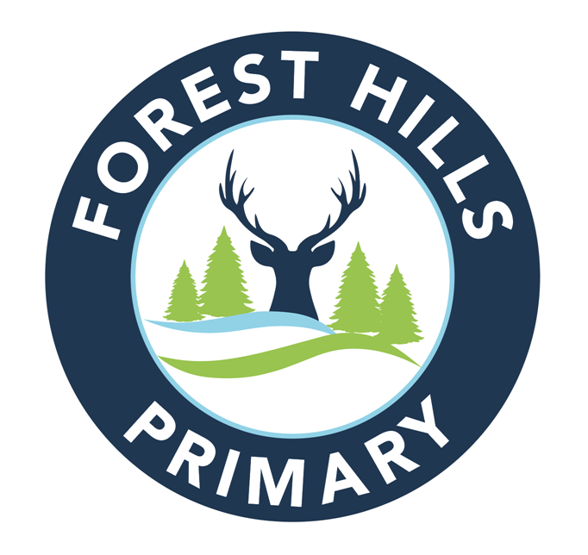

Forest Hills Primary School
Uniform Policy

Document Control Table

Title | Forest Hills Primary School Uniform Policy
Author | Sarah Powell (Headteacher)
Date Approved | September 2025
Approved By Name | Ashley Knibbs (Chair of Governors)
Next Review Date | September 2026

Document History

Date | Author | Note of Revisions
July 2023 | SP | p.3 PE kit marked as ‘provided by school’, black shorts changed to navy
July 2025 | SP | Navy polo shirt added

FOREST HILLS PRIMARY SCHOOL
Uniform Policy
At Forest Hills we promote an inclusive environment, where every child has the right to achieve their potential regardless of their starting points.
. We will continue to interweave our school motto ‘Living, Learning, Growing’ and our core values into everything we do:


With this in mind, at Forest Hills Primary School, we aim to offer a uniform that unites our school and gives children a sense of belonging and pride, whilst ensuring that it is available at a reasonable cost and offers the best value for money for parents and carers.
Ensuring a uniform for all
At Forest Hills Primary School, it is important that our uniform unites our school community and develops a sense of pride in attending and representing our school. Our uniform is inclusive for all and does not discriminate against individuals.

Our school’s legal duties under the Equality Act 2010
The Equality Act 2010 prohibits discrimination against an individual based on the protected characteristics, which include sex, race, religion or belief, and gender reassignment.
To avoid discrimination, our school will:
- avoid listing uniform items based on sex, to give all pupils the opportunity to wear the uniform they feel most comfortable in or that most reflects their self-identified gender
- make sure that our uniform costs the same for all pupils
- allow all pupils to have long hair (though we reserve the right to ask for this to be tied back)
- allow all pupils to style their hair in the way that is appropriate for school yet makes them feel most comfortable
- allow pupils to request changes to swimwear for religious reasons
- allow pupils to wear headscarves and other religious or cultural symbols
- allow for adaptations to our policy on the grounds of equality by asking pupils or their parents to get in touch with Mrs S Powell, Headteacher, who can answer questions about the policy and respond to any requests

Limiting the cost of school uniform
Our school has a duty to make sure that the uniform we require is affordable, in line with statutory guidance from the Department for Education on the cost of school uniform.
We understand that items with distinctive characteristics (such as items that have to have a school logo) cannot be purchased from a wide range of retailers and that requiring many such items limits parents’ ability to ‘shop around’ for a low price.
We will make sure our uniform:
- is available at a reasonable cost
- provides the best value for money for parents/carers
We will do this by:
- limiting any items with distinctive characteristics to just our school jumper / cardigan
- limiting items with distinctive characteristics to low-cost or longer-lasting items
- considering cheaper alternatives to school-branded items, such as plain whit polo shirts
- avoiding specific requirements for items pupils could wear on non-school days, such as coats, bags and shoes
- keeping the number of optional items to a minimum, so that the school’s uniform can act as a social leveller
- avoiding different uniform requirements for different year / class / house groups
- avoiding different uniform requirements for extra-curricular activities
- making sure that arrangements are in place for parents to acquire second-hand uniform items
- avoiding frequent changes to uniform specifications and minimising the financial impact on parents of any changes
- consulting with parents and pupils on any proposed significant changes to the uniform policy and carefully considering any complaints about the policy

Expectations for school uniform
Our school’s uniform:
Navy blue ‘Forest Hills’ school logo sweatshirt or cardigan
Grey trousers, shorts, skirt or dress
Blue checked dress (summer option)
White or navy polo shirt (school logo polo shirts are optional)
Black socks or tights
Black shoes

PE kit:
White t-shirt (provided by school)
Navy shorts (provided by school)
Coloured ‘house’ t-shirts (provided by school)
Black pump / trainers

Other optional branded items:
Navy-blue ‘Forest Hills’ school logo coat
Navy-blue ‘Forest Hills’ school logo book bag.

Expectations for jewellery and hairstyles
- One pair of studs only to be worn for school. These should be removed or covered for PE.
- Hair should be neat and tidy
- Long hair should be neatly tied back
- Unnatural hair dye should not be used
- Patterns and designs should not be shaved into hair

Where to purchase it
School uniform can be purchased locally at two uniform stores. They are as follows:

Blueprint Designs
www.blueprint-designs.co.uk
2 Brewery Street, Rugeley WS15 2DY
01889 800644

Blueprint Designs offers parents and carers flexible prepayment plans, enabling the cost of uniform to be paid over several months.

Uniforms Plus
Unit 2 Anson Street, Rugeley WS15 2BB
01889 575515

Second-hand uniform can be exchanged at school toward the end of a Summer term and as uniform is available. Victory Church, Rugeley also offers a local uniform exchange scheme across all Rugeley primaries.

Expectations for our whole school community
Children
Children are expected to wear the correct uniform at all times (other than specified non-school uniform days) while:
- on the school premises
- travelling to and from school
- at out-of-school events or on trips that are organised by the school, or where they are representing the school (if required)
Children are also expected to contact Mrs S Powell (Headteacher) if they want to request an amendment to the uniform policy in relation to their protected characteristics.

Parents and carers
Parents and carers are expected to make sure their child has the correct uniform and PE kit, and that every items of uniform are:
- clean
- clearly labelled with the child’s name
- in good condition
Parents are also expected to contact Mrs S Powell (Headteacher) if they want to request an amendment to the uniform policy in relation to:
- their child’s protected characteristics
- the cost of the uniform
Parents are expected to lodge any complaints or objections relating to the school uniform in a timely and reasonable manner.
Disputes about the cost of the school uniform will be:
- resolved locally
- dealt with in accordance with our school’s complaints policy
The school will work closely with parents to arrive at a mutually acceptable outcome.

Staff
Staff will closely monitor children to make sure they are in correct uniform. They will give any children and families breaching the uniform policy the opportunity to comply, but will follow up with the Headteacher if the situation does not improve. Ongoing breaches of our uniform policy will be dealt with by the Headteacher. In cases where it is suspected that financial hardship has resulted in a pupil not complying with this uniform policy, staff will take a mindful and considerate approach to resolving the situation.

Governors
The governing board will review this policy and make sure that it:
- is appropriate for our school’s context
- is implemented fairly across the school
- takes into account the views of parents and pupils
- offers a uniform that is appropriate, practical and safe for all pupils
The board will also make sure that the school’s uniform supplier arrangements give the highest priority to cost and value for money, for example by avoiding single supplier contracts.

Monitoring arrangements
This policy will be reviewed annually by the Headteacher. At every review, it will be approved by the full governing board.

Links to other policies
This policy is linked to our:
Behaviour policy
Equality information and objectives statement
Anti-bullying policy
Complaints policy

